邵武一中2021届高三九月月考英语试卷答案
第一部分：听力(共20小题；每题1.5分，满分30分)
1-5 ACBAB 6-10 CBAAA 11-15ACCAB 16-20CBCBC
第二部分：阅读理解(共两节，满分35分)
第一节(共10小题；每小题2.5 分，满分25分)
21-25 DACAB 26-30 DBCDC
第二节(共5小题；每小题2分，满分10分)
31-35 FDCAG
第三部分：语言运用(共两节，满分45分)
第一节：完形填空(共20小题；每小题1.5分，满分30分)
36-40 DCDAB 41-45 BDAAD 46- 50 BCABC 51-55 CCBAD
第二节：语法填空(共10小题；每小题1.5 分，满分15分)
56. up 57. it 58. to distinguish 59. researching 60. be caught
61. However 62. a 63. which 64. successfully 65. determined
第四部分：写作(共两节，满分40分)
第一节 应用文写作(满分15分)
A possible version:
Dear Mr. Smith,
Facing a tough problem of how to make a film review, I am writing to ask you for a favour.
Next month, our school is going to have an English film review competition, where competitors are supposed to comment on a certain English film. I intend to participate in it, but I have no clear knowledge of how to make a film review, like what aspects should be involved. I was wondering if you could give me a brief explanation and recommend me some relevant books and articles.
Your early reply will be highly appreciated.
Yours,
Li Hua
第二节 读后续写 (满分25分)
A possible version:
We tried stopping vans as they were driving down the street. I learned something about New York drivers that day: They don’t stop; they speed up. Then we tried waiting by the light. We’d go over, knock on the window and the driver would roll it down, looking at us in alarm, and I’d ask if he would drive us to Harlem so we could help some people. Every time the driver would look away quickly, furiously roll up the window and pull away without saying anything. My wife was ready to give up, but I said, “It’s the law of averages; somebody is going to say yes.”
Eventually a van drove up and the driver said yes. We were wild with joy and climbed onto the van. Upon arrival, he led us to a store where we bought lots of food and some baskets. Together we packed them up, carried them onto the van and went to buildings where there were even people living without electricity. It was a truly fulfilling experience to make even a small difference. You see, you can make anything happen if you commit to it and take action. Miracles like this happen every day—even in a city where “there are no vans.”
【解析】
A【考点】
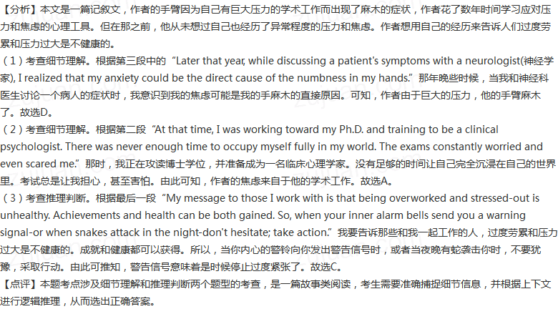
B
【解析】
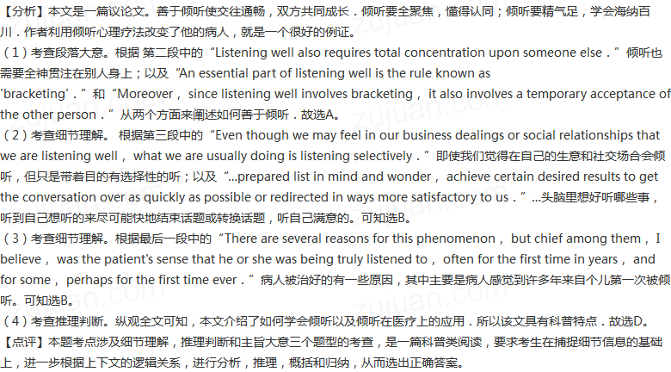

C【分析】
这是一篇说明文。文章主要说明了每个人都会拖延，这是人类状态的一部分。研究拖延症的Tim Pychyl的研究表明人们可以拖延几乎任何事情，甚至是愉快的任务，如计划假期。文章还分析了导致人们拖延的一些因素，以及拖延带来的不良后果。
27. 细节理解题。根据第一段中“It's part of the human condition, ”says procrastination researcher Tim Pychyl. “We want to feel good now. The way to do that is avoid the task.” He admits that in the short term, procrastination is powerfully rewarding. The present self-benefits, of course, but not the future self.可知“这是人类状态的一部分，”研究拖延症的Tim Pychyl说。“我们现在想要感觉良好。这样做的方法是避免任务。他承认，从短期来看，拖延是非常有益的。当然，现在的自我利益，而不是未来的自我利益。由此可知，Tim Pychyl认为，人们拖延是因为它能提供暂时的缓解。故选B。
28．句意猜测题。根据第三段中Kelli Saginak, a 57-year-old health coach from Wisconsin, procrastinated about looking for a new job for years. That inability to take action only confirmed her belief that she would never do any better. “It's totally fear of judgment,” says Saginak.可知来自威斯康辛州、现年57岁的健康教练Kelli Saginak拖延了好几年才开始找新工作。无法采取行动只会让她坚信自己永远不会做得更好。“这完全是对评判的恐惧，”Saginak说。由此可知，Kelli Saginak所说的“Yet it's simply me judging myself”的意思是她后悔没有采取行动。故选C。
29．细节理解题。根据第四段中“I did an experiment, putting procrastinators under restrictions of time. They did worse than non-procrastinators, but they thought they did better.” says Joseph Ferrari, a psychology professor. “Non- Procrastinators focus on the task that needs to be done. They have a stronger personal identity and are less concerned about what psychologists call social esteem's how others like us.”可知“我做过一个实验，将拖延者置于时间限制之下。他们比不拖拉的人做得更差，但他们认为自己做得更好。”心理学教授Joseph Ferrari说。“非拖延者会专注于需要完成的任务。他们有更强的个人认同感，不太关心心理学家所说的社会尊重，即别人如何喜欢我们。”由此可知，Joseph Ferrari的实验说明了不拖拉的人在限定的时间内表现得更好。故选D。
30．推理判断题。根据最后一段中Procrastination is usually not going to be good for you. Just thinking about what you haven't done may cause discomfort.可知拖延症通常对你没有好处。仅仅想到你没有做的事情可能会让你感到不适。由此可推知，作者对拖延症的态度是反对的。故选C。
【解析】


